Q-1. Which of the following constraint requires that there should not be duplicate entries?

Ans- C) Null

Q-2. Which of the following constraint allows null values in a column?

Ans- A) Primary key

Q-3. Which of the following statements are true regarding Primary Key?

Ans- D) All of the above

Q-4. Which of the following statements are true regarding Unique Key?

Ans- D) All of the above

Q-5. Which of the following is/are example of referential constraint?

Ans- B) Foreign Key

Q-6. How many foreign keys are there in the Supplier table?

Ans- C) 2

|  |  |
| --- | --- |
| ID | Marks |
| 4625 | 79 |
| 5505 | 56 |
| 6501 | 65 |

Q-7. The type of relationship between Supplier table and Product table is:

Ans- A) one to many

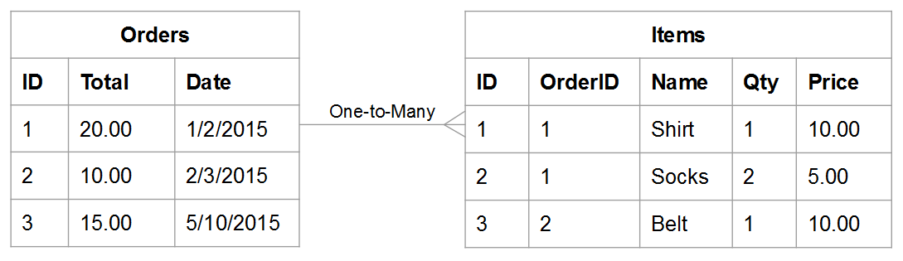

Q-8. The type of relationship between Order table and Headquarter table is:

Ans- A) one to many

|  |  |
| --- | --- |
| Orders | Items |

|  |  |  |  |  |  |  |  |  |  |
| --- | --- | --- | --- | --- | --- | --- | --- | --- | --- |
| ID | Total | Date |  |  | ID | Order ID | Name | Qty | Price |
| 1 | 40 | 02.04.2022 |  |  | 1 | 1 | T-shirt | 1 | 40 |
| 2 | 20 | 03.04.2022 |  |  | 2 | 1 | Shirt | 2 | 10 |
| 3 | 30 | 04.04.2022 |  |  | 3 | 2 | Socks | 1 | 30 |

Q-9. Which of the following is a foreign key in Delivery table?

Ans- D) None of them

Q-10. The number of foreign keys in order details is:

Ans- A) 0

Q-11. The type of relationship between Order Detail table and Product table is:

Ans- A) one to many

18 18
81 8L
Order Details
* OrderID
8 ProductID
UnitPrice
Quantity
Discount
Customers
CustomerID
CompanyName
Contact Name
Con

Q-12. DDL statements perform operation on which of the following database objects?

Ans- C) Table

Q-13. Which of the following statement is used to enter rows in a table?

Ans- A) Insert in to

Q-14. Which of the following is/are entity constraints in SQL?

Ans- B) Unique

Q-15. Which of the following statements is an example of semantic Constraint?

Ans- A) A blood group can contain one of the following values - A, B, AB and O.